Project Outline: Backpacking wood stove

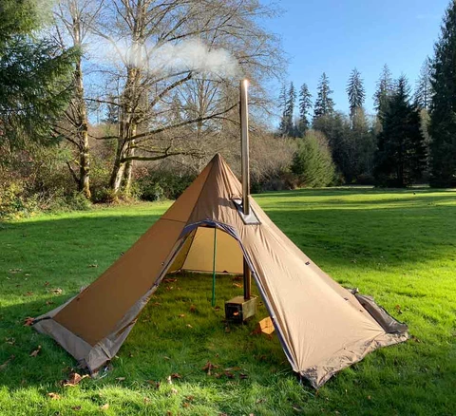

By Tyler Stafford

**Cover & Table of Contents**

Goals & Objectives of Project………………………….…………………….………...3

Project Leader Information…… ……………………………………………….………3

Detailed Itinerary (Including start and finish times, leaders, special activities, etc.)…………………..…………………………………………………………….……..5

Project Budget ..…………………………………………………………… …….…….8

Equipment and material information…………………………………………….……9

Identification of risks and dangers – suggestions for avoidance……………….…..9

Emergency Plan & Phone Numbers…………………….…………………………….10

Management Information - Permits, parking, etc….………..……………………….11

Useful graphics and project statistics …………….. ……………………………..….12

Historical Information…………………………….……………………………………. 13

Resources ……………………………………………………………………………….14

Objective

Create a durable, lightweight, and cost-effective wood stove that can strap onto a backpack for hot tenting purposes.

Project leaders bio.

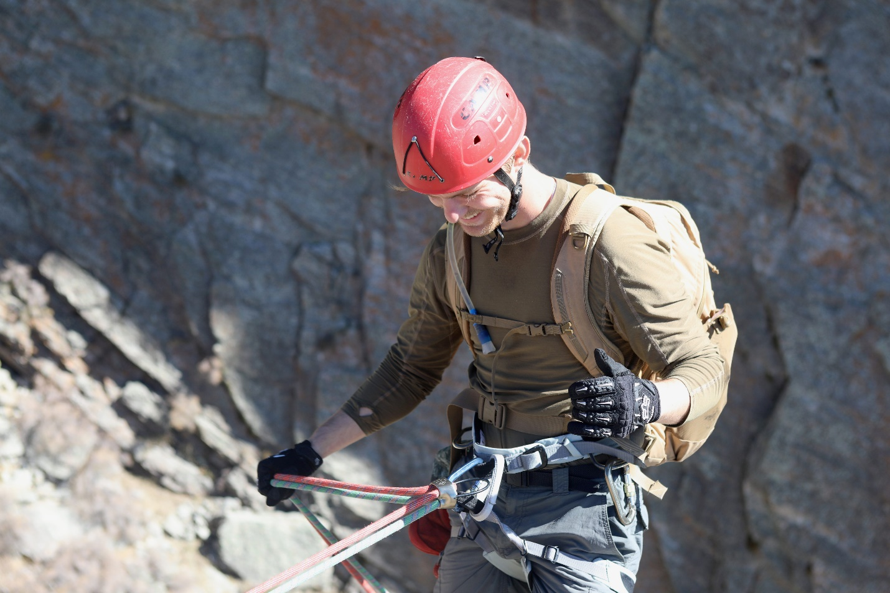

Tyler Stafford: My name is Tyler Stafford and I am an aspiring Special Forces SERE Specialist for the Air Force. I am an Eagle Scout and have grown up all my days in the outdoors. I am graduating with a degree in Healthcare Administration this coming July. I got this idea to create a backpacking wood stove from spending a cold night outside with my cumbersome and outright heavy sleeping bag and still being cold despite it. The wood stove would provide me with comfort in a wide array of outdoor temperatures.

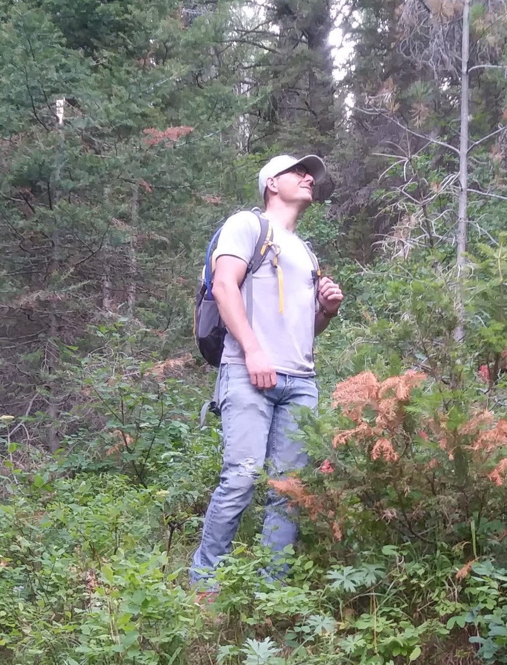Eric Rawlinson (Engineer/ welding specialist): Eric is also an Eagle Scout and will be graduating from Brigham Young University this December with a bachelor’s in mechanical engineering. Eric has worked as a welder in the Wyoming oil fields for years and now has a job with Honeywell as a Engineer/ welding specialist. Eric enjoys hunting, camping, and creating things with his hands.

Project Itinerary

Activity list

1. Discuss what is needed in a backpacking woodstove
2. Create design/prototype (Gather supplies, create, and test stove)
3. Upload design onto engineering software
4. Gather materials
5. Discuss how to procced with cutting and assembling stove (ex. Cut metal with plasma cutter of band saw)
6. Get certifications and rent out equipment
7. Cut materials
8. Assemble materials
9. polish up stove
10. Test stove

c

2 h

J

5 h

I

1 h

H

3 h

F

1week

G

2 h

E

1 h

D

4 h

B

1 week

A

3days

**Week 1**

(Activities A, B)

Monday:

Tuesday: Discuss what is needed for backpacking wood stove

Wednesday: Create design

Thursday:

Friday:

Saturday: No work on weekend

Sunday: No work on weekend

**Week 2**

(Activities B)

Monday: Get materials for prototype

Tuesday: Assemble prototype

Wednesday: Assemble prototype

Thursday: Assemble prototype

Friday: Test prototype

Saturday: No work on weekend

Sunday: No work on weekend

**Week 3**

(Activities C,D,E)

Monday:

Tuesday: Upload design/ talk about what we need to rent.

Wednesday:

Thursday:

Friday: Get materials

Saturday: No work on weekend

Sunday: No work on weekend

**Week 4**

(Activities F)

Monday: Get certification from teacher to use equipment.

Tuesday:

Wednesday:

Thursday: Get each other’s schedules for the next week

Friday: Rent equipment

Saturday: No work on weekend

Sunday: No work on weekend

**Week 5**

(Activities G,H,I)

Monday: Cut materials on plasma cutter

Tuesday:

Wednesday: Weld together stove

Thursday:

Friday: Polish stove

Saturday: No work on weekend

Sunday: No work on weekend

**Week 6**

(Activities J)

Monday:

Tuesday: Test stove initial burn

Wednesday:

Thursday: Test stove inside tent.

Friday:

Saturday: No work on weekend

Sunday: No work on weekend

**Week 7**

(Present to class and have meeting with Brother Godfrey)

Monday: Review project outline

Tuesday:

Wednesday: Present to class

Thursday:

Friday: Meeting with Brother Godfrey

Saturday: No work on weekend

Sunday: No work on weekend

Project Budget

Budget for prototype: $40

Budget for Finished project: $50

Equipment and materials needed

(According to what we discussed in activities B,C,D,E)

Materials

* 22 gauge carbon steel
* Stove pipe
* Hinges
* Wood (For stove testing)
* Lighter (For stove testing)

Equipment

* Plasma cutter (Including safety clothing)
* Welder (Including safety clothing)
* Steel cutter (Including safety clothing)
* Grinder (Including safety clothing)
* Drill (Including safety clothing)
* Vice
* Ruler
* Tent (For design and testing purpose)

Identification of Risk and Dangers

* Design phase (creating a design that could potentially be dangerous)(Drinking to much soda)
* Plasma cutter (Burns, blindness, loss of fingers, carbon monoxide emissions)
* Welder (Burns, blindness, carbon monoxide emissions, explosion)
* Steel cutter (loss of fingers and limbs)
* Grinder (burns, metal dust inhalation, load noise, carbon monoxide emissions)
* Drill (Drill going through your hand)
* Testing stove in tent (Tent catching on fire, carbon monoxide emissions, burns, catching surrounding materials on fire, cutting oneself splitting wood)

Emergency plan and contacts

* Design phase (creating a design that could potentially be dangerous) Be clear about design to Eric so he understands what will and won’t work (Drinking to much soda) Be moderate in all things
* Plasma cutter (Burns, blindness, loss of fingers, carbon monoxide emissions) First aid kit in shop, If someone is ok then have them take the other to the emergency room.
* Welder (Burns, blindness, carbon monoxide emissions, explosion) First aid kit in shop, If someone is ok then have them take the other to the emergency room.
* Steel cutter (loss of fingers and limbs) First aid kit in shop, If someone is ok then have them take the other to the emergency room.
* Grinder (burns, metal dust inhalation, load noise, carbon monoxide emissions) First aid kit in shop, If someone is ok then have them take the other to the emergency room.
* Drill (Drill going through your hand) First aid kit in shop, If someone is ok then have them take the other to the emergency room.
* Testing stove in tent (Tent catching on fire, carbon monoxide emissions, burns, catching surrounding materials on fire, cutting oneself splitting wood) Take person to emergency room.

Contacts

* 911
* Eric’s ins (In his wallet)
* Tyler’s ins (In his wallet)
* Eric’s wife (Saved on Eric’s and Tyler’s phone)
* Tyler’s wife (Saved on Eric’s and Tyler’s phone)

Management information

Permits

* Parking pass for campus (unless after 4pm)

Certifications

* Online certification for welding shop
* How to use plasma cutter
* How to use Steel cutter
* How to use welder
* How to use drill
* How to use grinder

Authorizations (From teacher that is over this equipment)

* Plasma cutter
* Steel cutter
* Welder
* Drill
* Grinder

Rentals (All equipment listed above must be rented for $10 per hour for one hour)

Project Statistics

That means our wood stove is over 120% cheaper than our lowest ranking competition.

“First – and very important in a cold environment – is that you can get your clothing and footwear dry and free of moisture on a regular basis. This means your clothing will perform up to its maximum potential while out and about during the day. A warm space also allows you to properly air out your sleeping bag on a daily basis. Moisture in your clothing and sleeping kit will significantly reduce their performance.”

“A tent stove isn’t just for keeping you warm either. Your stove provides a heat source on which to cook, produce hot drinks and melt snow to produce water.”

“A tent heated by a wood-burning stove is a much more efficient way to keep warm and cook than an open fire outside. You will burn much less fuel, which means gathering less firewood. This saves time, effort and calories as well being kinder on the local environment. Even a relatively lightweight canvas tent containing an efficient wood stove can quickly create a comfortable atmosphere of +20-25 Celsius inside while it is minus 20 to 30 Celsius outside.”

To try and put this more into perspective, during the month of October which is prime hunting season the ***average*** temperature at night is 6 degrees Fahrenheit in Wyoming (which is known for its hunting and outdoor adventure). A sleeping bag (in which you would still be cold) that you would need in that temperature would be a 0 degree bag which cost on the low end $72 and upwards to $700. You would never use this bag during the summer and it is only good for sleeping in. If it gets wet then it becomes useless.

A wood stove is good during the winter, summer, when its wet, when its windy, and is more low impact on the environment than building a fire outside of you tent, and is more fuel efficient then a fire outside.

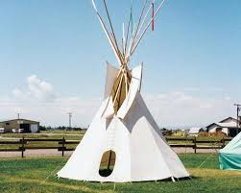Historical information

Indians often lived in tipis which is made up of animals’ skins that is wrapped around a frame of wooden poles. There is a flap at the top of the tent which enables the residents of the tipi to have a fire inside. The smoke of the fire would escape through the top of the tipi which is slightly offset from the middle. This allows the residents of the tipi to close the flap partially to block any kind of rain or snow but still allow the smoke to escape.

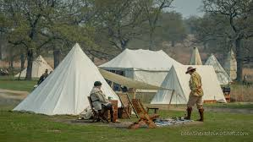Mountain Men used kind of the same system of tent but also incorporated wedge shelters and walled canvas tents if they had the money. The technology though at the time still didn’t allow easily portable stoves to go inside their tent, but they did have lodges in the winter with fire in their lodge in which smoke would escape through the roof. These lodges were their kind of home base that they stayed throughout the winter.

Now a days hot tenting is pretty posh with lightweight material and titanium wood stoves that fold up to the 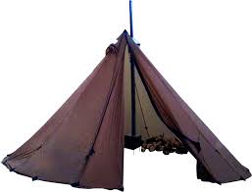size of a small dish to store in you backpack with a smoke pipe that rolls up like you would see a roll of duct tape.

Resources

*Google Search*, Google, [www.google.com/search?q=backpacking%2Bwood%2Bstove&rlz=1C1CHBF_enUS720US720&oq=back&aqs=chrome.0.69i59j69i57j0l2j69i65j69i61.1155j0j7&sourceid=chrome&ie=UTF-8](http://www.google.com/search?q=backpacking%2Bwood%2Bstove&rlz=1C1CHBF_enUS720US720&oq=back&aqs=chrome.0.69i59j69i57j0l2j69i65j69i61.1155j0j7&sourceid=chrome&ie=UTF-8).

Kirtley, and Paul. “How To Live In A Heated Tent.” *Paul Kirtley's Blog*, Paul Kirtley's Blog, 13 Mar. 2016, paulkirtley.co.uk/2014/how-to-live-in-a-heated-tent/.

“0 Degree Super Down Sleeping Bag.” *KUIU*, www.kuiu.com/shop/sleep-system/sleeping-bags/super-down-sleeping-bag-0/81003-MP-R.html?utm_source=google&utm_medium=cpc&adpos=1o7&scid=scplp81003-MP-R&sc_intid=81003-MP-R&gclid=Cj0KCQiAno_uBRC1ARIsAB496IWMVUQshPxg0wd9gYraTUJi6hR_nOp0VPbTFsSblb-XcVDtmK1q49gaAnS0EALw_wcB.

“Tipi Tepee TeepeeNative Americansin Olden Times for Kids.” *Plains Indians - Teepees, Tipi, Tepee - Native Americans in Olden Times for Kids*, nativeamericans.mrdonn.org/plains/teepees.html.

Evaluations

1. Help me understand how you have grown as a project manager in a 1) dependent 2) independent and 3) interdependent mode

After our initial interview on how I was doing in the class It reminded me of judgement day and how we discuss what we did, how we have changed, and if we think we should make it to the celestial kingdom or not.

After taking the Christlike evaluation model the questions in the diligence (humility as well) part I feel really emphasized what this class was about. I have struggled with this for a long time but it is now after this class I can say that I have actually changed my character. This change in character helped me with the dependent mode in that I always showed up to class and applied what was taught to my projects, the independent mode because I went out and found an internship, and my interdependent mode because we took a design on a computer and less than 6 weeks later we had the stove going in my tent. I did all of this without being told and without waiting till the last moment to get it done.

What I feel I have in my tool belt now in terms of knowledge and abilities is that I

* Can work well with other people and was able to get the class going and project going by using this skill
* I don’t have to be told what to do to get things done
* I used Project management methods to help me organize and obtain my goals
* I documented the time and resources it took to complete my project
* I used patience in during times when I couldn’t get the materials
* I used creativity when creating a prototype
* I was humble in listening to Bro Godfrey when he came with suggestions

1. Please account for the time that you have spent growing as a project manager this semester

Go to Time Tracking Google Sheet

1. What progress have you made with the 5 outcomes of the course

Be an effective communicator, team member, and leader (more than one role)

Be proactive, able to operate in poorly defined or constrained situations (be the force to bring clarity out of ambiguity)

I helped create the class from nothing

Know how to create, coordinate, execute, and evaluate a project and a project plan (become fluent in professional project formats and documentation)

Be able to list and define the core principles of project management, identify and implement multiple methodologies, and explain how they can be used to make a project successful (become fluent in professional processes and practices)

GQM (Goal, Question, Metric)

Waterfall Method

Agile Method (The delivering of product to the coustomer for feedback was the idea with the prototype)

Fibonacci sequence (As a method of Project Management in scaling things up)

Be self-regulated, life-long learners (grow in self-mastery)

1. What progress have you made with managing and improving the quality of the 1) deliverables and/or results of projects 2) processes by which project deliverables and results are achieved 3) personal growth and development of yourself as well as your team members

In the end if I am hold myself to these outcomes listed above and I can prove that I have grown in all areas of those outcomes then I have completed what expected and should get an A.

I personally think I should get an A- because my documentation for my Independent project was weak and my knowledge retention of what we talked about in class is weak.